Club Officers 1974-1975

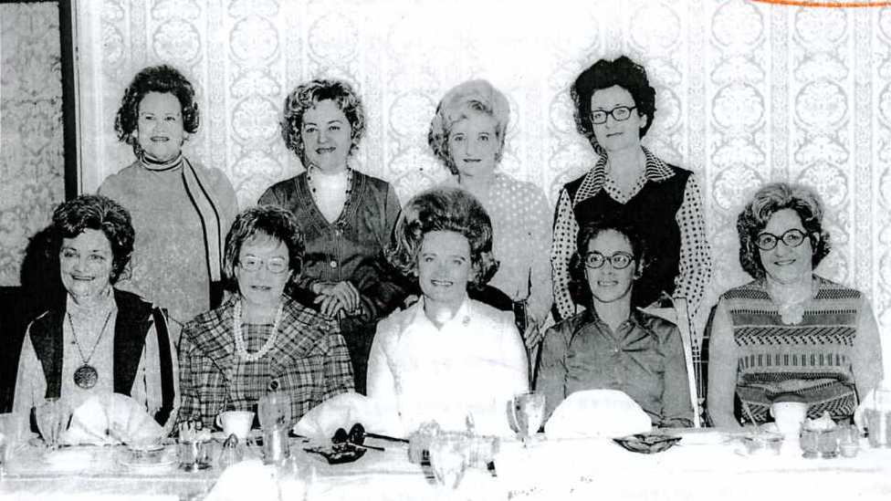

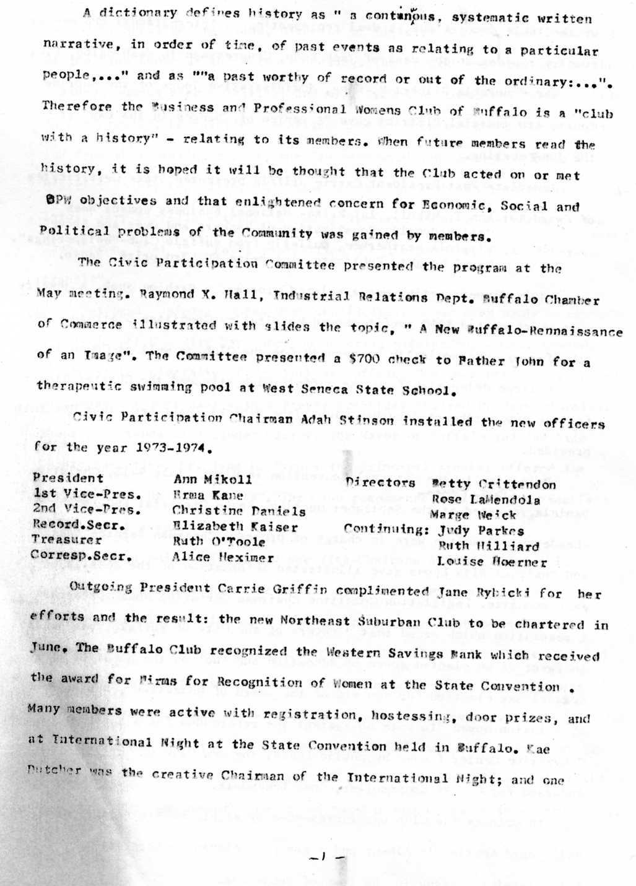

Of the table decorations, a doll representing an International BPW member country resides on the desk of Jack Kemp, Congressman in Washington, D.C.
The Honorable Gilbert H. King, Administrative Judge of the Supreme Court, 8th Judicial District gave “A Review of Changes in the Law” at the June meeting.
Immediate Past President Carrie Griffin presented State Certificates of Award to: Ann T. Mikoll, 1st Prize-National Business Womens Week
Ceil McDonald, Equalization of Members and Over and Above
Virginia Weatherbee, Bulletin from Buffalo Club- “Whisperings”
Caryl Knight, Publicity, 1st prize, 3rd prize, Radio
July dinner meeting was a relaxed program, a Fashion Show. A jewelry sale which netted $160 profit showed Hospitality Committee Chairman Marge Schaefer was “Economically concerned” for the Club as well as Community.
A large delegation from the Buffalo Club attended the Charter dinner for the new Northeast Suburban Club. Jane Rybicki, past New Clubs Chairman presided.
Delegates to the National Convention in Miami, July 9-12, Christine Daniels and Betty Kaines reported at the September meeting. Young Careerist and Youth Leadership Committee were in charge of program. Chairman Bernice Engel and Chairman Rita Lyons gave illustrated information of the details of each committee. Legislation Committee Chairman Christine Nowak presented a resolution which urged that “voters of the City of Buffalo vote ‘yes’ in favor of an elected Board of Education and ‘no’ on the question of a special May election for members of the Board of education”. Another resolution moved “to vote no against the referendum for a Buffalo Convention Center funded by public funds”. The BPW Club of Buffalo endorsed for County Comptroller, Rose LaMendola.
In October the Club was represented by eight members at the State Fall Board meeting in Albany and a group of eleven members attended the Fall District meeting in the Town of Tonawanda.

Mrs. Rosalind Drexelius, Director of District 8 and a Past President of the Club spoke at the October meeting. The Program was arranged by the Business Womens Week Committee; and Mrs. Drexelius topic was “Women’s Role in Leadership”. Legislation Committee held a “Hear the Candidates” night, and from that meeting report, the Club endorsed Jane Storoscia for 9th District County Legislator and Susan Lubick for 10th District County Legislator. Mary Fiorells attended a community forum to make the views of the Club known, that is, “favor rapid transit but oppose any form of overhead transit.”
National Business Womens Week unofficially began when members attended a pre-kickoff Community Day Luncheon honoring outstanding women sponsored by the State University of New York at Buffalo. The week officially opened on Sunday, October 21st with a Prayer Breakfast chaired by Mary Fiorella. Those in attendance included Clergy, the Mayor of Buffalo and the Erie County Executive Dr. Jane L. Syrnes the principle speaker offered the message “Lift Up Your Hearts”. The Club recommended that Prayer Breakfast be an annual event.
Chairman Enid Robinson and her Vice-Chairman Alfreda Slominski arranged to place women in the public eye. President Ann T. Mikoll, Jane Rybicki, and Alfreda Slominski were interviewed by John Corbett on his TV program “Contact”. Discussion included Women’s Roles in the 1970s, ERA and the history and objectives of BPW. There were also radio announcements during the week as well as newspaper coverage of all events.
On October 24th the entire Buffalo City Hall was “taken over” by BPW members. Under supervision and planning of Councilwoman Alfreda Slominski, “Women in City Government” proved how capable women can be in government.

Purpose of the day was to encourage women to become better informed about the operation of city government and to encourage more women to take an active interest in politics and in seeking office.
The Civic Participation Committee hosted a Halloween Card Party for Buffalo State Hospital Clients (resident patients). Members purchased tickets to be given to the clients as well as providing donuts, cider, coffee and prizes on October 26th.
The final event of Business Womens Week was the Scholarship Show Luncheon. The Club honored Dr. Eleanor Jacobs as the “Woman of the Year”. At Veterans Administration Hospital, Dr. Jacobs is a Clinical Psychologist who does research and publishes the effects of Hyperbaric Oxygenation and its use in Medicine.
It was in October that the Board chose to invite the Parliamentarian Sande Zempe to attend all meetings since the Board recognized her definite role as Parliamentarian of the Club.
“Associate’s Night” was arranged by the Personal Development Committee at the November meeting. Speaker Mr. C. Rhodes Palmer of Advest Investment Firm chose “How to Make Money” for his message to members and associates.
Members attended on November 29th the formal opening of the special Exhibit honoring Outstanding Women entitled “Only a Woman”. The pictorial exhibit and accompanying audio-visual presentation was first discussed by Justice Ann T. Mikoll of BPW and Dr. Walter S. Dunn, Director of the Buffalo accomplishments of women from Colonial times to World War II, and the special accomplishments of women who were either born or resided in Western New York.

